a)

avi@ROY:~/Desktop$ touch 20301269_1.txt 20301269_2.txt 20301269_3.txt 20301269_4.txt

avi@ROY:~/Desktop$ mkdir avi1 avi2

avi@ROY:~/Desktop$ mv 20301269_1.txt 20301269_2.txt 20301269_3.txt avi1

avi@ROY:~/Desktop$ cp avi1/20301269_1.txt avi2

avi@ROY:~/Desktop$ cp avi1/20301269_2.txt avi2

avi@ROY:~/Desktop$ mkdir avi3

avi@ROY:~/Desktop$ cp -r avi1 avi3

avi@ROY:~/Desktop$ cd avi3

avi@ROY:~/Desktop/avi3$

avi@ROY:~/Desktop/avi3$ ls -l avi1

total 0

-rw-rw-r-- 1 avi avi 0 জুলাই 8 14:51 20301269_1.txt

-rw-rw-r-- 1 avi avi 0 জুলাই 8 14:51 20301269_2.txt

-rw-rw-r-- 1 avi avi 0 জুলাই 8 14:51 20301269_3.txt

avi@ROY:~/Desktop/avi3$ chmod g=rx,o=rx 20301269_1.txt 20301269_2.txt 20301269_3.txt

chmod: cannot access '20301269_1.txt': No such file or directory

chmod: cannot access '20301269_2.txt': No such file or directory

chmod: cannot access '20301269_3.txt': No such file or directory

avi@ROY:~/Desktop/avi3$ cd ..

avi@ROY:~/Desktop$ ls -R

.:

20301269_4.txt avi1 avi2 avi3

./avi1:

20301269_1.txt 20301269_2.txt 20301269_3.txt

./avi2:

20301269_1.txt 20301269_2.txt

./avi3:

avi1

./avi3/avi1:

20301269_1.txt 20301269_2.txt 20301269_3.txt

avi@ROY:~/Desktop$ sudo su

[sudo] password for avi:

root@ROY:/home/avi/Desktop# mv avi3 /

root@ROY:/home/avi/Desktop# rm -r avi1 avi2 20301269_4.txt

root@ROY:/home/avi/Desktop#

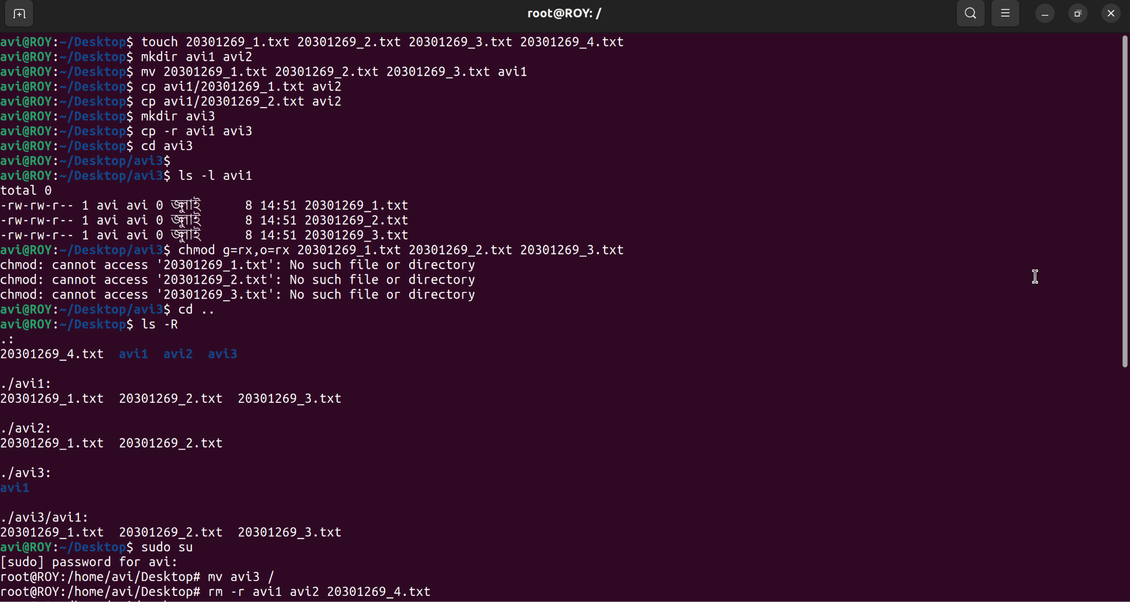

b)

root@ROY:/home/avi/Desktop# cat > course.txt

CSE321- Operating System -section 09

CSE460 - VLSI DESIGN -section 06

CSE341 - Microprocessor -section 07

CSE421 - Computer Networks -section 06

CSE400 -THESIS

^C

root@ROY:/home/avi/Desktop# grep CSE course.txt

CSE321- Operating System -section 09

CSE460 - VLSI DESIGN -section 06

CSE341 - Microprocessor -section 07

CSE421 - Computer Networks -section 06

CSE400 -THESIS

root@ROY:/home/avi/Desktop#

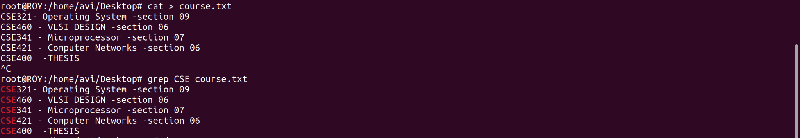

c)

root@ROY:/home/avi/Desktop# cd /

root@ROY:/# ls -a

. .. avi3 bin boot cdrom dev etc home lib lost+found media mnt opt proc root run sbin snap srv swapfile sys tmp usr var



d)

root@ROY:/# cat > file.txt

THIS IS LINE 1

THIS IS LINE 2

THIS IS LINE 3

THIS IS LINE 4

THIS IS LINE 5

THIS IS LINE 6

THIS IS LINE 7

THIS IS LINE 8

THIS IS LINE 9

THIS IS LINE 10

THIS IS LINE 11

THIS IS LINE 12

THIS IS LINE 13

THIS IS LINE 14

THIS IS LINE 15

THIS IS LINE 16

THIS IS LINE 17

^C

root@ROY:/# sed -n '5,17p' file.txt

THIS IS LINE 5

THIS IS LINE 6

THIS IS LINE 7

THIS IS LINE 8

THIS IS LINE 9

THIS IS LINE 10

THIS IS LINE 11

THIS IS LINE 12

THIS IS LINE 13

THIS IS LINE 14

THIS IS LINE 15

THIS IS LINE 16

THIS IS LINE 17

root@ROY:/#

